**LEBANESE AMERICAN UNIVERSITY**

**USAID – HIGHER EDUCATION SCHOLARSHIP PROGRAM**

**HES - Volunteering Program Verification Form**

This form is to be used to document volunteering hours. If a student volunteers for multiple organizations, a separate form must be used for each organization. **This form must be turned in by the 28th of each month, the latest.**

I certify that the scholar Shadi Haidar completed a total of 5 hours of service at InnovaThrive.

The hours were completed hours as per the below:

Hours # 0 (date) _2/12 – 6/12_ (initials of supervisor) __A.K.___

Hours # 0 (date) _9/12 – 13/12_ (initials of supervisor) __A.K.___

Hours # 0 date) _16/12 – 20/12 (initials of supervisor) __A.K.___

Hours # 5 date) _23/12 - 27/12 (initials of supervisor) __A.K.___

Brief description of the activities the scholar performed or participated in:

I did research on the role of AI in the detection and prescribing of medication.

Written feedback about the scholar’s performance:

Shadi Haidar’s research on the role of AI in the detection and prescribing of medication demonstrated clear focus and relevance. Unfortunately, his volunteering form was submitted late. This late submission is unacceptable and should be avoided in future tasks to maintain smooth workflow and professionalism.

Please rate the overall performance of the scholar at your organization:

|  |  |  |  |
| --- | --- | --- | --- |
|  | Mastery (5) | Proficient (3) | Emerging (1) |
| **Problem solver** | X |  |  |
| **Engaged & Committed** | X |  |  |
| **Open-minded & multicultural** | X |  |  |

Signature

& stamp

__________________________

_

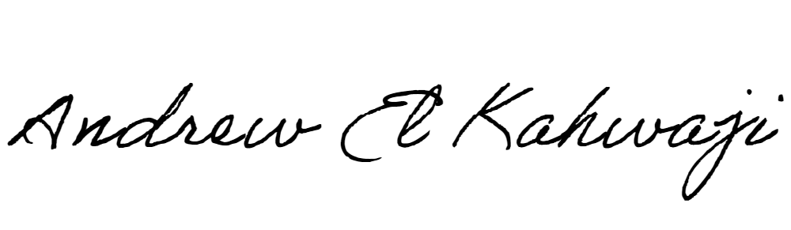

Printed Name _Andrew El Kahwaji_

Date __26/12/2024___

Email __andrew.lifesculptor.coo@gmail.com __

Phone __+961 71 914 378__